**Project 1: *Sì-Wŭ-Liù***

**(a.k.a. Cee-lo)**

**Danziel Nguyen**

**CSC5-40772**

**Introduction:**

Title: Sì-Wŭ-Liù

Sì-Wŭ-Liù is a basic dice gambling game played with three dice. It is often played in urban areas and was especially popular with Chinese-Americans. The American variant of the game “Cee-lo” has been referenced throughout the years in rap and hip-hop, aiding in the popularity of the game.

Sì-Wŭ-Liù can be played either with a banker or not. The game is generally most often played with a banker, and so the variant shown in my program is done with a predetermined banker with a single player. Similarly to craps, it uses a point system for dice rolls along with specific roll combinations. The banker normally changes from player to player but in this program it will not. The banker sets up an initial stake or “bank” and the other players will bet until the entire bank is covered or the players do not wish to bet further. If any portion of the bank is not covered, the uncovered amount is given back to the banker and the game proceeds with the stakes that were covered.

The banker rolls the dice once bets have been made. When the dice are rolled, four types of outcomes are possible:

If the banker rolls a 4, 5, and 6, called 4-5-6 straight kill, or if all three dice are the same (triples), or if the banker rolls a non-6 pair with an individual 6, it is an automatic win and the banker collects all bets.

If the banker rolls a 1, 2, and 3, called 1-2-3 straight loss, or if the banker rolls a non-1 pair with an individual 1, it is an automatic loss and the players break the bank.

If the banker rolls a pair and a single, the single dice is the banker’s “point”.

If the banker does not roll any of the above combinations, they roll again until they do so.

If the banker rolls a point, the players roll the dice to decide winners individually against the banker’s point.

The outcomes are the same except players do not automatically win with a non-6 pair with a single 6 and they do not automatically lose with a non-1 pair with a single 1.

If the player rolls a point, the point is compared to the banker’s point. The player wins with a higher point, lose with a lower point, if the points are tied the player rolls again.

The payouts differ based on variant however generally a 4-5-6 roll pays two times the bet, a roll of all 1s pay five times the bet, and regular non-1 triples pay three times the bet.

**Program Summary:**

Lines: about 450

Variables: 19

Libraries: 9

User Functions: 7

**Pseudocode:**

Libraries:

iostream

cstdlib

ctime

fstream

cctype

math.h

algorithm

vector

string

Variables:

Static const int: size

Int: bDice[], point1, point2, pickSort

char: betAsk

bool: betting, bRoll, pRoll, logResult

const float: bank, stBal

float: noCover, cover, bet, bankbal, balance

vector: pDice

string: pName

Display starting bank and player balance

Roll banker’s dice

Begin betting phase

Ask if the player wants to bet

If no: end

If yes: ask how much

If bank is covered, end betting phase

If bank is not covered, return to start of betting phase

Sort dice from least to greatest

Check dice combinations:

Three of the same , 4 5 6, non-6 pair with 6 are automatic win 1 2 3, non-1 pair with 1 are automatic lose

Pair with single => single is the point

If none of these, roll again

If there is a point, set that point for the banker (point1)

Roll player’s dice

Check dice combinations:

1 1 1 automatic win, bet * 5

Three of the same automatic win, bet * 3

4 5 6 automatic win, bet *2

1 2 3 automatic lose

Pair with single => single is the point

If none of these, roll again

If there is a point, set that point for the player (point2)

If there are two points, compare them

If the banker is higher, banker wins

If the player is higher, player wins

Display the final bank balance and player balance

Ask if the player wants to output the result to file

If no, end program

If yes, open records.txt

Write end balances to file

Close records.txt

End program

**Flowchart:**

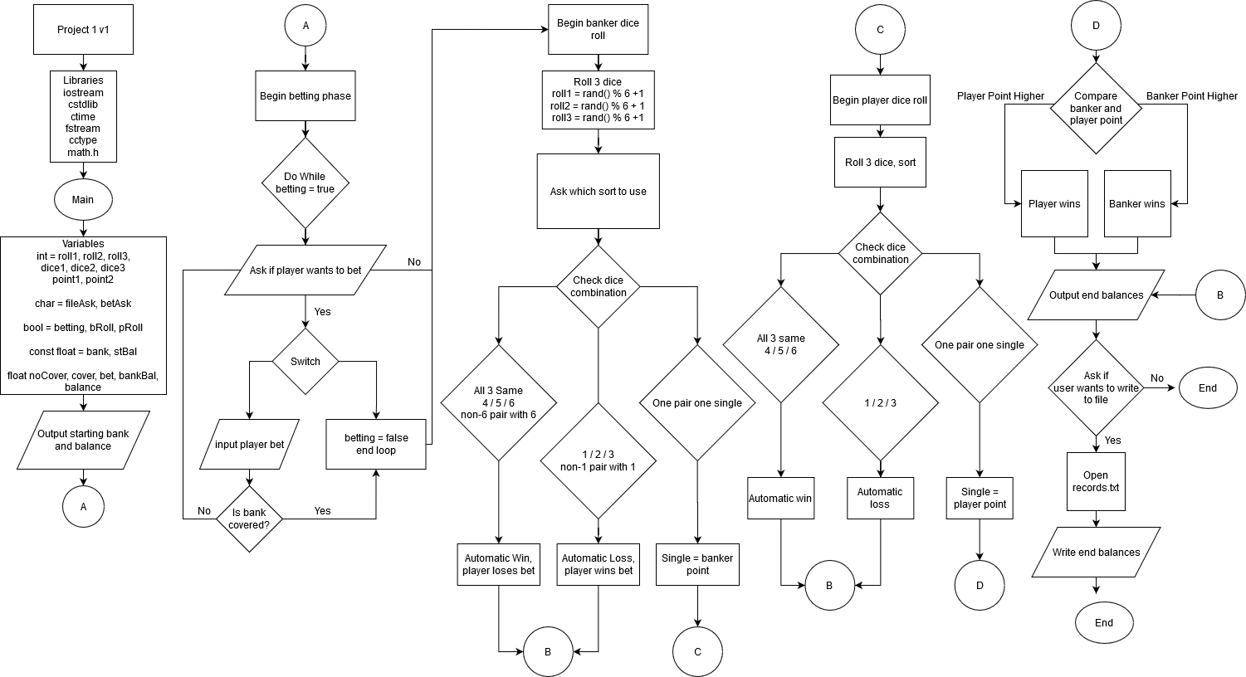

**Input and Output Example**

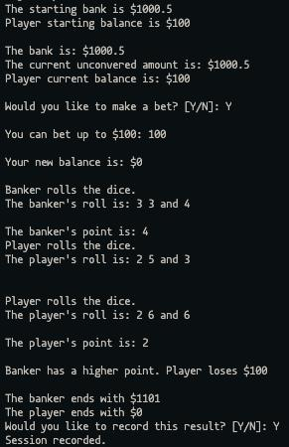

Cross-List_From_Proj1

**Cross Reference from Project 1**

You are to fill-in with where located in code

|  |  |  |  |  |  |
| --- | --- | --- | --- | --- | --- |
| **Chapter** | **Section** | **Topic** | **Where Line #''s** | **Pts** | **Notes** |
| 2 | 2 | cout | 59 |  |  |
|  | 3 | libraries | 15 | 5 | iostream, iomanip, cmath, cstdlib, fstream, string, ctime |
|  | 4 | variables/literals | 44 |  | No variables in global area, failed project! |
|  | 5 | Identifiers | 44 |  |  |
|  | 6 | Integers | 45 | 1 |  |
|  | 7 | Characters | 46 | 1 |  |
|  | 8 | Strings | 52 | 1 |  |
|  | 9 | Floats No Doubles | 50 | 1 | Using doubles will fail the project, floats OK! |
|  | 10 | Bools | 47 | 1 |  |
|  | 11 | Sizeof ***** |  |  |  |
|  | 12 | Variables 7 characters or less | 44 |  | All variables <= 7 characters |
|  | 13 | Scope ***** No Global Variables |  |  |  |
|  | 14 | Arithmetic operators | 105 |  |  |
|  | 15 | Comments 20%+ |  | 2 | Model as pseudo code |
|  | 16 | Named Constants | 49 |  | All Local, only Conversions/Physics/Math in Global area |
|  | 17 | Programming Style ***** Emulate |  |  | Emulate style in book/in class repositiory |
|  |  |  |  |  |  |
| 3 | 1 | cin | 56 |  |  |
|  | 2 | Math Expression | 105 |  |  |
|  | 3 | Mixing data types **** |  |  |  |
|  | 4 | Overflow/Underflow **** |  |  |  |
|  | 5 | Type Casting |  | 1 |  |
|  | 6 | Multiple assignment ***** |  |  |  |
|  | 7 | Formatting output | 62 | 1 |  |
|  | 8 | Strings | 59 | 1 |  |
|  | 9 | Math Library | 21 | 1 | All libraries included have to be used |
|  | 10 | Hand tracing ****** |  |  |  |
|  |  |  |  |  |  |
| 4 | 1 | Relational Operators | 85 |  |  |
|  | 2 | if | 146 | 1 | Independent if |
|  | 4 | If-else | 95 | 1 |  |
|  | 5 | Nesting | 208 | 1 |  |
|  | 6 | If-else-if | 208 | 1 |  |
|  | 7 | Flags ***** |  |  |  |
|  | 8 | Logical operators | 95 | 1 |  |
|  | 11 | Validating user input | 85 | 1 |  |
|  | 13 | Conditional Operator | 457 | 1 |  |
|  | 14 | Switch | 93 | 1 |  |
|  |  |  |  |  |  |
| 5 | 1 | Increment/Decrement | 390 | 1 |  |
|  | 2 | While | 85 | 1 |  |
|  | 5 | Do-while | 74 | 1 |  |
|  | 6 | For loop | 390 | 1 |  |
|  | 11 | Files input/output both |  | 2 |  |
|  | 12 | No breaks in loops ****** |  |  | Failed Project if included |
|  |  |  |  |  |  |
|  |  |  |  |  |  |
| ****** Not | required to | show | Total | 30 |  |

Cross_List_For_Proj2

**Cross Reference for Project 2**

**You are to fill-in with where located in code**

i

|  |  |  |  |  |  |
| --- | --- | --- | --- | --- | --- |
| **Chapter** | **Section** | **Topic** | **Where Line #''s** | **Pts** | **Notes** |
| 6 |  | Functions | 389 |  |  |
|  | 3 | Function Prototypes | 32 | 4 | Always use prototypes |
|  | 5 | Pass by Value |  | 4 |  |
|  | 8 | return | 459 | 4 | A value from a function |
|  | 9 | returning boolean | 459 | 4 |  |
|  | 10 | Global Variables |  | XXX | Do not use global variables -100 pts |
|  | 11 | static variables | 45 | 4 |  |
|  | 12 | defaulted arguments | 426 | 4 |  |
|  | 13 | pass by reference | 389 | 4 |  |
|  | 14 | overloading | 396 | 5 |  |
|  | 15 | exit() function | 137 | 4 |  |
| 7 |  | Arrays | 46 |  |  |
|  | 1 to 6 | Single Dimensioned Arrays | 46 | 3 |  |
|  | 7 | Parallel Arrays |  | 2 |  |
|  | 8 | Single Dimensioned as Function A | rguments 389 | 2 |  |
|  | 9 | 2 Dimensioned Arrays |  | 2 | Emulate style in book/in class repositiory |
|  | 12 | STL Vectors | 52 | 2 |  |
|  |  | Passing Arrays to and from Functio | ns 389 | 5 |  |
|  |  | Passing Vectors to and from Funct | ons 396 | 5 |  |
|  |  |  |  |  |  |
| 8 |  | Searching and Sorting Arrays | 415 |  |  |
|  | 3 | Bubble Sort | 415 | 4 |  |
|  | 3 | Selection Sort | 426 | 4 |  |
|  | 1 | Linear or Binary Search |  | 4 |  |
|  |  |  |  |  |  |
|  |  |  |  |  |  |
| ****** Not | required to | show | Total | 70 | Other 30 points from Proj 1 first sheet tab |